Timbuctoo: African American Settlement
Education Material
Background: In the 1840s, Gerrit Smith gave away thousands of acres of land to African Americans. Review the source below and answer the following questions.
NYS Social Studies Standards:
- 7.7b Enslaved African Americans resisted slavery in various ways in the 19th century. The abolitionist movement also worked to raise awareness of and generate resistance to the institution of slavery.
- 11.3b Different perspectives concerning constitutional, political, economic, and social issues contributed to the growth of sectionalism.
Questions:
- How much land did each person receive?
- Where did the land recipients live when they received their deed to the land?
- Why would African Americans want to move to unimproved land in the Adirondack Mountains?
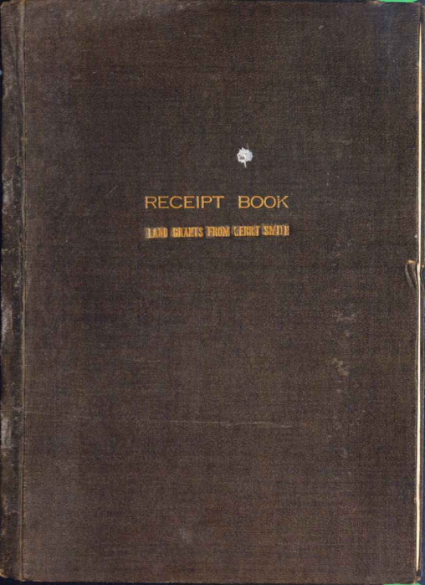 | 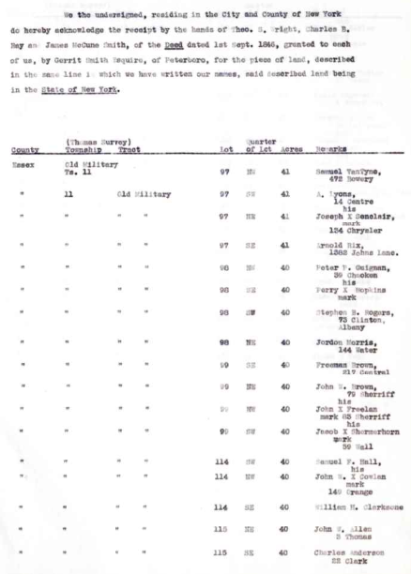
In the 1840s, Gerrit Smith gave away thousands of acres of land to African Americans. This copy of his receipt book lists the land transactions during 1846.
Source: https://digitalcollections.archives.nysed.gov/index.php/Detail/objects/72601
Cover and page 6

